Modern College of Arts, Science and Commerce (Autonomous), Pune-05

Bachelor of Science

Electronic Science

Mini Project

Counter Circuit

Made by

***Nikhil K. Kavate***

Third Year, Bachelor of Science (Electronics)

Roll no. 43270

**INDEX**

|  |  |  |  |  |
| --- | --- | --- | --- | --- |
| Sr  No. | Content | Page no. | Remark | Sign |
| 1 | Introduction | 3 |  |  |
| 2 | About CD 4206 | 3 |  |  |
| 3 | Working of the circuit | 4 |  |  |
| 4 | Diagram | 5-7 |  |  |
| 5 | Circuit Diagram | 7 |  |  |
| 6 | Construction | 8 |  |  |
| 7 | Application | 9 |  |  |
| 8 | Reference | 9 |  |  |
| 9 | Component Required | 10 |  |  |

* **INTRODUCTION**

We count everything in order to project or show the count value we need number display and here simple seven segment counter circuit designed to show the count value in single digit seven segment LED display. This circuit will show and increase the number digit when the count key pressed.

* **About CD 4026**

CD4026 is a Johnson counter IC commonly used in digital display. It has a 5 stage Johnson decade counter with a decoder which converts the Johnson code to 7 segments decoded output. It converts the input into numeric display and can be seen on 7 segment display or with LED. It can be used for displaying analogue value such as temperature with pic microcontroller or for counting objects. There are various other applications like in 7 segment decimal display circuit, in clocks, timer etc. Advantages of 4026 counter are: It contains counters and 7 segment decoded in one package, it can be easily interfaced with 7 segment types, Ideal for low power display, operated at wide range of voltage from 5V to 20V and the biggest advantage of the 4026B counter IC is that it can drive a 7-segment display without needing a decoder driver IC.

* **Working of the circuit**

I have interfaced the 7 segments to the CD 4026, PIN 4 & 14 are left open as I haven't used them, PIN 15 used to Reset the counter with the help of a PUSH button Switch. PIN 2 is kept LOW to avoiding the freezing and PIN 13 is kept HIGH to enable the IC.

Now, another main component of this circuit, other than CD 4026, is 555 timer IC. 555 timer is used here to provide the clock pulse on each Button Press, whenever we press the button the counter advance by one. 555 Timer IC is used here in Monostable mode.

I have also used a RC circuit (10uf capacitor and 100k resistor) at CLOCK PIN 1 of CD 4026, so that it only counts one clock pulse on each time button is pressed. Otherwise, circuit may behave unexpectedly OR it can count two or more pulses because of noise or bouncing effect of Push button.

* **Diagram**

Seven segment display :-

 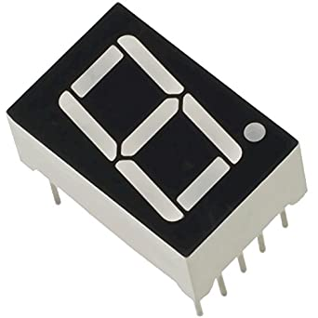

CD 4026 :-

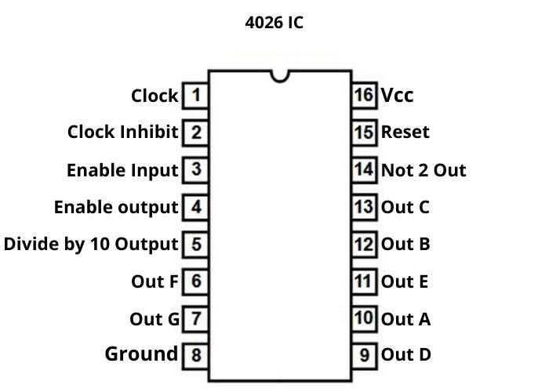 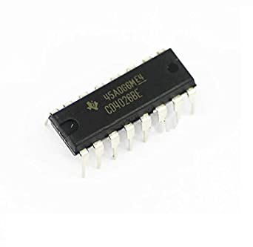

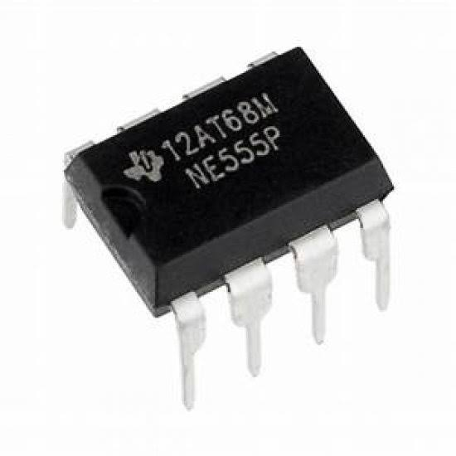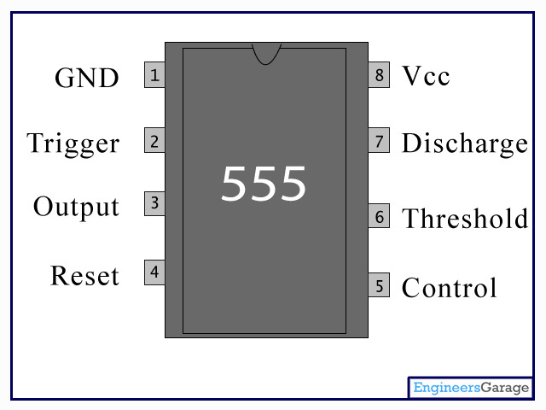 IC 555 :-

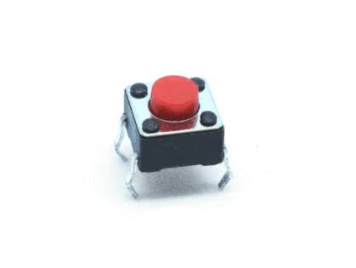Push Button :-

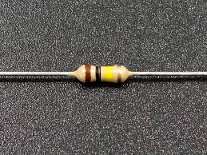Resistor :-

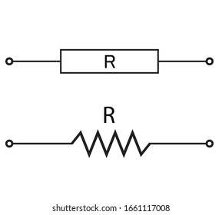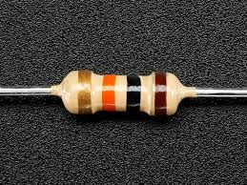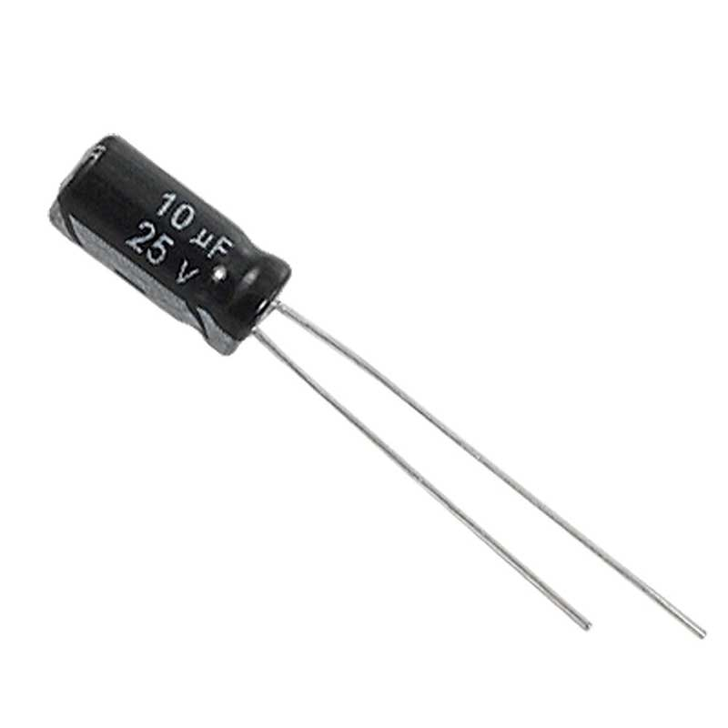Capacitor :-

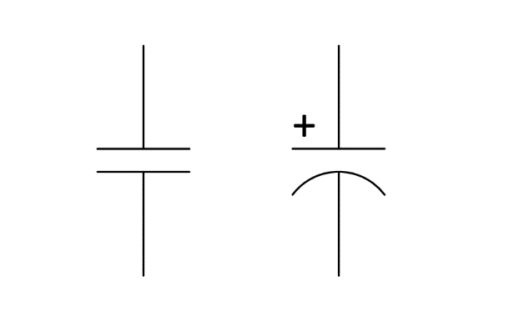

* 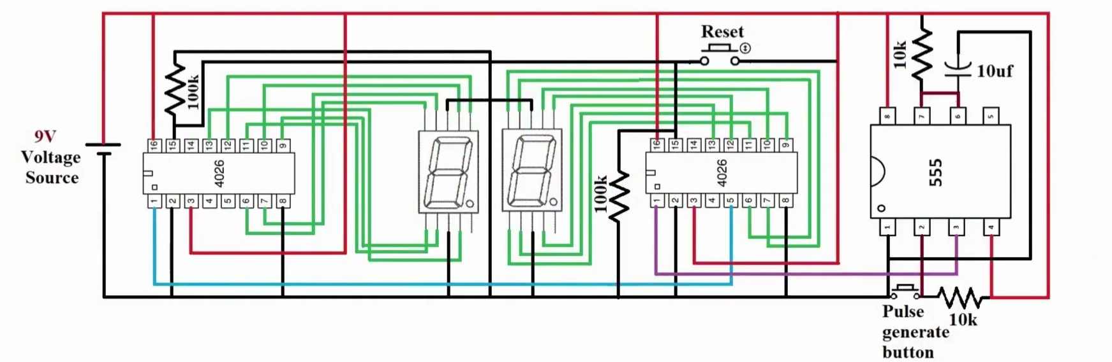 **Circuit Diagram**
* **Construction:** -

1. Mount two seven segment display and 3 – IC’s on breadboard side by side.
2. 555 IC pin 1 goes to ground.
3. 555 IC pin 2 goes to +vcc through 10k resistor.
4. 555 IC pin 4 goes to +vcc.
5. 555 IC pin 6 shorted with pin 7.
6. 10µf capacitor (+)ve terminal connect with 555 timer pin 6 or 7 (-)ve terminal goes to ground.
7. 10k resistor connect with 555 ic pin 6 or 7 and +vcc.
8. 555 IC pin 8 goes to +vcc.
9. CD 4026 pin 2 goes to ground.
10. CD 4026 pin 3 goes to +vcc.
11. 555 timer pin 3 goes to CD 4026 pin 1.
12. 1st digit driver CD 4026 pin 5 goes to 2nd digit driver CD 4026 pin 1.
13. CD 4026 pin 8 goes to ground.
14. CD 4026 pin 10 goes to 7 segment display pin A.
15. CD 4026 pin 12 goes to 7 segment display pin B.
16. CD 4026 pin 13 goes to 7 segment display pin C.
17. CD 4026 pin 9 goes to 7 segment display pin D.
18. CD 4026 pin 11 goes to 7 segment display pin E.
19. CD 4026 pin 15 goes to ground through 100k resistor.
20. CD 4026 pin 16 goes to +vcc.
21. CD 4026 pin 6 goes to 7 segment display pin F.
22. CD 4026 pin 7 goes to 7 segment display pin G.
23. Push button connect across 555 timer pin 1 and 2.
24. 1 st digit CD 4026 pin 15 goes to 2nd digit CD4026 pin 15.
25. Push botton connect for reset across cd 4026 pin 15 & 16.
26. Connect voltage source.

* **Applications: -**

Applications of Seven Segment Displays are these displays are commonly used in timers, clock radios, digital clocks, calculators and wristwatches. These devices can also be found in speedometers, motor-vehicle odometers, and radio frequency indicators.

* **Reference: -**

Google and YouTube.

Click here to Watch the Video



* **Component Required: -**

|  |  |  |  |
| --- | --- | --- | --- |
| **SR No.** | **Component name** | **Specification** | **Unit** |
| **1** | **CD 4026 Driver IC** | **-** | **2** |
| **2** | **555 Timer IC** | **-** | **1** |
| **3** | **Seven segment display** | **Common cathode** | **2** |
| 4 | **Resistor** | **100k ohm** | **2** |
|  |  | **10k ohm** | **2** |
| **5** | **Capacitor** | **10µF** | **1** |
| **6** | **Power supply** | **5v – 9v** | **1** |
| **7** | **Breadboard** | **-** | **1** |
| **8** | **Single strand wire** | **1m** | **2** |
| **9** | **Push button** | **-** | **2** |